Supplementary Material
Optical modeling of spectral backscattering and remote sensing reflectance from Emiliania huxleyi blooms

Griet Neukermans*, Georges Fournier
* Correspondence: Griet Neukermans: griet.neukermans@obs-vlfr.fr

Supplementary methods and results

Geometric cross-section of an elliptical lith
The canonical equation of the ellipse is, with parameters shown in Supplementary Figure 1:

$$\frac{x^{2}}{a^{2}}+\frac{y^{2}}{b^{2}}=1$$
(S1)

The ratio of the semi-major axis to the semi-minor axis is:

$$r=\frac{a}{b}$$
(S2)

The surface area of an ellipse is given by:

$$A_{e}=πab$$
(S3)

The eccentricity is:
$$ϵ=\sqrt{1-\frac{b^{2}}{a^{2}}}$$
(S4)

The circumference or perimeter of an ellipse is:

$$P_{e}=4 a E\left(ϵ^{2}\right)$$
(S5)

Where $E\left(ϵ\right)$ is the complete elliptic integral of the second kind (Abramowitz and Stegun, 1964):

$$E\left(ϵ^{2}\right)=\int_{0}^{π/2}{\sqrt{1-ϵ^{2}\sin^{2}{θ}} dθ}$$
(S6)

There is a very simple accurate approximate formula available that was derived by Ramanujan (1914) which will be very convenient to use in our work
$$P_{e}\left(a,b\right)=π\left(a+b\right) \left[1+\frac{3h}{10+\sqrt{4-3h}}\right]$$
(S7)

$$h=\frac{{\left(a-b\right)}^{2}}{{\left(a+b\right)}^{2}}$$
(S8)

The formula is accurate to order $h^{5}$. For an ellipse with a ratio of major to minor axis of 2 the error would be of the order of 0.00002. Following the theorem due to Cauchy (1850) for the average projected area of randomly oriented convex shapes we have for the geometric cross-section of randomly oriented elliptical coccoliths:

$$σ_{gl}=\left(\frac{1}{4}\right)\left[2π\left(ab\right)+τ_{l}{ P}_{e}\left(a,b\right)\right]$$
(S9)

We can rewrite our equations for the perimeter in terms of the normalized quantities defined in the main text as follows:
$$P_{e}\left(a,b\right)=πa_{o}\left(\frac{a}{a_{o}}+\frac{b}{a_{o}}\right) \left[1+\frac{3h}{10+\sqrt{4-3h}}\right]$$
(S10)

$$h=\frac{{\left(\frac{a}{a_{o}}-\frac{b}{a_{o}}\right)}^{2}}{{\left(\frac{a}{a_{o}}+\frac{b}{a_{o}}\right)}^{2}}$$
(S11)

This results in a simple non-dimensional form for the perimeter of the various ellipses of the coccolith
$$P_{e}\left(a,b\right)=πa_{o}P_{n}\left(\frac{a}{a_{o}},\frac{b}{a_{o}}\right)$$
(S12)

with:
$$P_{n}\left(\frac{a}{a_{o}},\frac{b}{a_{o}}\right)=\left(\frac{a}{a_{o}}+\frac{b}{a_{o}}\right) \left[1+\frac{3h}{10+\sqrt{4-3h}}\right]$$
(S13)

and

$$σ_{gl}=\left(\frac{1}{4}\right)\left[2π\left(ab\right)+τ_{l}πa_{o}P_{n}\left(\frac{a}{a_{o}},\frac{b}{a_{o}}\right)\right]$$
(S14)

where $τ_{l}$ is the thickness of the elliptical disk.

Generalized shifted gamma distribution

To check if there is a better fit to the measured coccolith particle size distributions by Young et al. (2014) than the first order shifted gamma distribution used in our earlier work (Fournier and Neukermans, 2017) we will use the generalized Gamma function:
$$P\left(z-z_{min}\right)=\frac{νβ^{\frac{m+1}{ν}}}{Γ\left(\frac{m+1}{ν}\right)}{\left(z-z_{min}\right)}^{m}e^{-β{\left(z-z_{min}\right)}^{ν}}$$
(S15)

To obtain a formula for the mean we need to split the integral as follows:

$$μ=\int_{zmin}^{∞}{z p\left(z-z_{min}\right)}dz=\int_{zmin}^{∞}{(z-z_{min⁡)} p\left(z-z_{min}\right)dz}+z_{min}\int_{zmin}^{∞}{p\left(z-z_{min}\right)dz}$$

$$μ=z_{min}+\frac{Γ\left(\frac{m+2}{ν}\right)}{Γ\left(\frac{m+1}{ν}\right)β^{\frac{1}{ν}}}$$

We need to take the same approach for the standard deviation

$$σ^{2}=\int_{zmin}^{∞}{{\left(z-μ\right)}^{2} p\left(z-z_{min}\right)}dz$$

Given that we can expand as follows:

$${\left(z-μ\right)}^{2}={\left[\left(z-z_{min}\right)+\left(z_{min}-μ\right)\right]}^{2}$$
$$={\left(z-z_{min}\right)}^{2}+2\left(z_{min}-μ\right)\left(z-z_{min}\right)+{\left(z_{min}-μ\right)}^{2}$$

Integrating each part and grouping we get:

$$σ^{2}=\left(\frac{Γ\left(\frac{m+3}{ν}\right)}{Γ\left(\frac{m+1}{ν}\right)}-\frac{{Γ\left(\frac{m+2}{ν}\right)}^{2}}{{Γ\left(\frac{m+1}{ν}\right)}^{2}}\right)\left(\frac{1}{β^{\frac{2}{ν}}}\right)$$

$$σ=\sqrt{\left(\frac{Γ\left(\frac{m+3}{ν}\right)}{Γ\left(\frac{m+1}{ν}\right)}-\frac{{Γ\left(\frac{m+2}{ν}\right)}^{2}}{{Γ\left(\frac{m+1}{ν}\right)}^{2}}\right)}\left(\frac{1}{β^{\frac{1}{ν}}}\right)$$

We are now in a position to express $β$ and $z_{min}$ in terms of the mean and standard deviation of the distribution.
$$β={\left(\frac{Γ\left(\frac{m+3}{ν}\right)}{Γ\left(\frac{m+1}{ν}\right)}-\frac{{Γ\left(\frac{m+2}{ν}\right)}^{2}}{{Γ\left(\frac{m+1}{ν}\right)}^{2}}\right)}^{\frac{ν}{2}}\left(\frac{1}{σ^{ν}}\right)$$

$$z_{min}=μ-\frac{σ}{\sqrt{\left(\frac{Γ\left(\frac{m+3}{ν}\right)Γ\left(\frac{m+1}{ν}\right)}{{Γ\left(\frac{m+2}{ν}\right)}^{2}}-1\right)}}$$
(S16)

If we substitute these expressions for $β$ and $z_{min}$ in the original expression for the size distribution we have a formula which now depends on the following variable.

$$P\left(m,ν,μ,σ,z\right)=\frac{ν{β\left(m,ν,σ\right)}^{\frac{m+1}{ν}}}{Γ\left(\frac{m+1}{ν}\right)}{\left(z-z_{min}\left(m,ν,μ,σ\right)\right)}^{m}e^{-β{\left(z-z_{min}\left(m,ν,μ,σ\right)\right)}^{ν}}$$
(S17)

Given measured distributions with known $μ$ and $σ$ we can estimate the best values to use for $m$ and $ν$ to model those distributions. We can even do a global fit over all distributions measured by Young et al. (2014) to obtain an overall best model for coccolith distributions.

The location of the peak of the distribution can also be found by solving the following equation.
$$\frac{∂p\left(m,ν,β,z_{min},z\right)}{∂z}=0$$
which gives:
$$z_{peak}=z_{min}+{\left(\frac{m}{νβ}\right)}^{\frac{1}{ν}}$$
(S18)

We can also rewrite the location of the peak in terms of the mean and standard deviation.
$$z_{peak}=μ-{\left(\frac{m}{ν}\right)}^{\frac{1}{ν}}\frac{σ}{\sqrt{\left(\frac{Γ\left(\frac{m+3}{ν}\right)}{Γ\left(\frac{m+1}{ν}\right)}-\frac{{Γ\left(\frac{m+2}{ν}\right)}^{2}}{{Γ\left(\frac{m+1}{ν}\right)}^{2}}\right)}}$$
(S19)

Finally another quantity of interest to us is the mean geometric cross-section. To obtain this in general we need to evaluate the following integral.

$$\overline{z^{2}}=\int_{zmin}^{∞}{z^{2} p\left(z-z_{min}\right)}dz$$
(S20)
Proceeding as before we have:

$${\left(z-z_{min}\right)}^{2}=z^{2}-2z_{min}z+z_{min}^{2}$$

$$z^{2}={\left(z-z_{min}\right)}^{2}+2z_{min}z-z_{min}^{2}$$

$$z^{2}={\left(z-z_{min}\right)}^{2}+2z_{min}\left(z-z_{min}\right)+2z_{min}^{2}-z_{min}^{2}$$

$$z^{2}={\left(z-z_{min}\right)}^{2}+2z_{min}\left(z-z_{min}\right)+z_{min}^{2}$$
(S21)

Performing the integrals and grouping the results we get:

$$\overline{z^{2}}=z_{min}^{2}+2z_{min}\frac{Γ\left(\frac{m+2}{ν}\right)}{Γ\left(\frac{m+1}{ν}\right)β^{\frac{1}{ν}}}+\frac{Γ\left(\frac{m+3}{ν}\right)}{Γ\left(\frac{m+1}{ν}\right)β^{\frac{2}{ν}}}$$
(S22)

In the special case where $ν=1$ we should note that the formulas above simplify considerably.
$$P\left(z-z_{min}\right)=\frac{β^{m+1}}{Γ\left(m+1\right)}{\left(z-z_{min}\right)}^{m}e^{-β\left(z-z_{min}\right)}$$
(S23)

$$μ=z_{min}+\frac{\left(m+1\right)}{β}$$
(S24)

$$σ^{2}=\frac{\left(m+1\right)}{β^{2}}$$
(S25)

$$σ=\frac{\sqrt{\left(m+1\right)}}{β}$$
(S26)

And for $β$ and $z_{min}$ in terms of the mean and standard deviation we have
$$β=\frac{\sqrt{\left(m+1\right)}}{σ}$$
(S27)

$$z_{min}=μ-\sqrt{\left(m+1\right)} σ$$
(S28)

Substituting in the original size distribution function we get:

$$P\left(m,μ,σ,z\right)=\frac{{β\left(m,σ\right)}^{m+1}}{Γ\left(m+1\right)}{\left(z-z_{min}\left(m,μ,σ\right)\right)}^{m}e^{-β\left(z-z_{min}\left(m,μ,σ\right)\right)}$$
(S29)

The location of the peak of the distribution is given by:

$$z_{peak}=z_{min}+\frac{m}{β}$$
(S30)

$$z_{peak}=μ-\frac{m σ}{\sqrt{m+1}}$$
(S31)

We can also obtain a simple expression for the term required in the evaluation of the mean cross-section.
$$\overline{z^{2}}=z_{min}^{2}+2z_{min}\frac{\left(m+1\right)}{β}+\frac{\left(m+1\right)\left(m+2\right)}{β^{2}}$$
(S32)

After using the complete set of size distribution functions measured by Young et al. (2014) we obtain that the best overall fit accounting for the variability is given by:

$$m=2 , ν=2$$

In that case we have the following simple expressions for the various parameter in terms of the mean and standard deviation of the distribution.

$$P\left(m,μ,σ,z\right)=\frac{{4β\left(m,σ\right)}^{\frac{3}{2}}}{\sqrt{π}}{\left(z-z_{min}\left(m,μ,σ\right)\right)}^{2}e^{-β{\left(z-z_{min}\left(m,μ,σ\right)\right)}^{2}}$$
(S33)

$$β=\frac{\left(3π-8\right)}{2π σ^{2}}$$
(S34)

$$z_{min}=μ- \frac{ σ}{\sqrt{\frac{\left(3π-8\right)}{8}}}$$
(S35)

$$z_{peak}=μ- \frac{ σ}{\sqrt{\frac{\left(3π-8\right)}{2 π}}}$$
(S36)

$$\overline{z^{2}}=z_{min}^{2}+4z_{min}\frac{1}{\sqrt{π β}}+\frac{3}{2 β}$$
(S37)

Supplementary Figure 2 shows the goodness of the fit to the 14 separate measured unity normalized coccolith size distributions from the data of Young et al. (2014). The distributions have been plotted in succession side by side and for reference the sampling interval for the original histograms was 0.2 μm. Note that each of the 14 distribution fits has precisely the mean and standard deviation measured for the corresponding experimental size distribution.

Algebraic remote sensing reflectance model

The algebraic remote sensing reflectance model of Albert and Mobley (2003) is based on the following simple equation which relates the backscattering albedo $x$ to the below-surface remote sensing reflectance for deep waters $R_{rs∞}$ (where there is no contribution from the bottom reflectance to the radiance signal at the surface):
$$R_{rs∞}=p_{1}x\left(1+p_{2}x+p_{3}x^{2}+p_{4}x^{3}\right)\left(1+p_{5}\frac{1}{\cos{θ_{s}}}\right)\left(1+p_{7}\frac{1}{\cos{θ_{v}}}\right)\left(1+p_{6}u\right)$$
(S38)

In the equation above $θ_{s}$ is the zenith angle of the sun under the water surface and $θ_{v}$ is the radiance sensor zenith viewing angle also below the water surface. $u$ is the mean wind speed in meters per second. The mean value over the world’s oceans is 6.9 m/s. The backscattering albedo is given by:
$$x\left(λ\right)=\frac{b_{b}\left(λ\right)}{b_{b}\left(λ\right)+a\left(λ\right)}$$
(S39)

The p-coefficients of Equation (S28) are given in Supplementary Table 1. The equation in the limit of small $x\left(λ\right)$ values approaches the classic result of Gordon et al. (1988):

$$R_{rs∞}=\frac{1}{π}\left(\frac{x\left(λ\right)}{3}\right)$$
(S40)

The complete form is however more accurate in the case where the backscattering albedo is moderate to large.
To obtain the above water remote sensing reflectance one can use the following simple expression (Lee et al., 1998):

$$R_{rs∞}^{+}=\frac{0.518 R_{rs∞}}{\left(1-1.562R_{rs∞} \right)}$$
(S41)

We now need to develop a model to evaluate the spectral backscattering and absorption coefficients. In general we have to account for the following components for absorption:

$a\left(λ\right)=a_{w}\left(λ\right)+a_{ph}\left(λ\right)+a_{cdom}\left(λ\right)+a_{nap}\left(λ\right)+a_{cc}\left(λ\right)$ (S42)
where $a_{w}\left(λ\right)$ is the absorption of pure water, $a_{ph}\left(λ\right)$ is the phytoplankton absorption due to chlorophyll-a absorption, $a_{cdom}$ is the absorption of colored dissolved organic matter, $a_{nap}\left(λ\right)$ is the absorption of non-algal particles and $a_{cc}\left(λ\right)$ is the absorption by coccolithophore cores. Note that we separate out the absorption by phytoplankton other than coccolithophores.
For the backscattering term we have
$$b_{b}\left(λ\right)=b_{bw}\left(λ\right)+b_{bph}\left(λ\right)+b_{bnap}\left(λ\right)+b_{bpic}\left(λ\right)$$
(S43)

where $b_{bw}\left(λ\right)$ is the backscattering coefficient of pure water, $b_{bph}\left(λ\right)$ for algal particles (other than coccolithophores), $b_{bnap}\left(λ\right)$ for non-algal particles, and $b_{bpic}\left(λ\right)$ for calcite particles, i.e. coccoliths and coccolithophores (see Equation 1 in main text). For the sake of simplicity we have set $b_{bnap}\left(λ\right)=0$ and $b_{bph}\left(λ\right)=0.$ The backscattering by pure water is computed using the formulations of (Zhang et al., 2009). To estimate the contributions to backscattering from the presence of coccoliths and coccolithophores to $b_{bpic}\left(λ\right)$ we use the cross-sections computed for bloom evolution represented by $σ_{bbs} \left(λ\right)$ and $σ_{bbNl} \left(λ\right)$ and fix the number concentration of coccolithophores in the bloom before they start shedding their liths, $N_{cc}$. We assume that the number of layers in a coccolithophore core ready to shed is 4. For a core of 4.4 μm in diameter, the size measured by Hoffmann et al. (2015), this gives a coating with 36 liths. For a core of 6 μm in diameter the same proportions give a coating with 44 liths.
$$b_{bpic}\left(λ\right)=N_{cc}\left[\left(1-F_{nc}\right)σ_{bbs} \left(λ\right)+F_{nc}σ_{bbNl} \left(λ\right)\right]$$
(S44)

As the bloom evolves, the fraction of naked cores $F_{nc}$ increases until all liths are free in the water and no cores are coated.

For the pure water absorption spectrum we use the combined data of (Kou et al., 1993) and (Pope and Fry, 1997). For the coccolithophore core contribution to absorption we use the absorption coefficient values $k\left(λ\right)$ of E. huxleyi determined by (Stramski et al., 2001) and (Neeley et al., 2015), shown in Supplementary Figure S4. We use the anomalous diffraction absorption efficiency $Q_{a}$ estimate (Jonasz and Fournier, 2007) and the integral over the size distribution of the core radius $r_{cc}$ to obtain the specific absorption coefficient of the coccolith cores. First note that $r_{cc}$ is directly related to the semi-major axis of the attached lith $a_{0}$ through the proportional relations suggested by Zhai et al. (2013):
$$r_{cc}=2\sqrt{a_{0}b_{0}}=2\sqrt{\frac{a_{0}^{2}}{r}}$$
(S45)
Therefore the same size distribution form as that for the corresponding $a_{0}$ applies to $r_{cc}$. The specific absorption coefficient of the coccolith cores is thus given by:

$a_{cc}^{*}\left(λ\right)=\int_{0}^{∞}{P\left(μ,σ,a_{0}\right)Q_{a}\left(k_{cc}\left(λ\right),r_{cc}\right)πr_{cc}^{2}}da_{0}$ (S46)
with
$$Q_{a}\left(k\left(λ\right),r_{cc} \right)=2\left[\frac{1}{2}+\frac{e^{-δ\left(λ\right)r_{cc}}}{δ\left(λ\right)r_{cc}}+\frac{\left(e^{-δ\left(λ\right)r_{cc}}-1\right)}{{\left(δ\left(λ\right)r_{cc}\right)}^{2}}\right]$$
(S47)
and
$$δ\left(λ\right)=4k\left(λ\right) \frac{2π}{λ}$$
(S48)

The total absorption from coccolithophores comes from both the coated cores and the naked cores that have shed all their liths. Denoting the fraction of naked cores by $F_{nc}$ and the fraction of surviving cores by $F_{sc}$, we have:
$$a_{cc}\left(λ\right)=N_{cc}F_{nc}F_{sc}a_{cc}^{*}\left(λ\right)+N_{cc}\left(1-F_{nc}\right)a_{cc}^{*}\left(λ\right)$$
(S49)

The first term on the right of the equation above represents the contribution of the naked cores to the coccolithophore absorption. We have used the fraction $F_{sc}$ to represent the portion of naked cores left in the surface layer after they have shed their liths. The second term represents the absorption contribution from the coated cores that have not yet completely shed their liths. In this term we have neglected the small loss of incident energy due to the backscattering by the lith coating.
For the CDOM absorption we use the following formula (Babin et al., 2003):
$$a_{cdom}\left(λ\right)=a_{cdom}\left(λ_{0}\right)e^{-β_{cdom}\left(λ-λ_{0}\right)}$$
(S50)

with $λ_{0}$ equal to 443 nm and $β_{cdom}$ equal to 0.0172 nm⁻¹ and $a_{cdom}\left(443\right)$ equal to 0.02 m⁻¹, mean values found in the North Atlantic (Babin et al., 2003). For the sake of simplicity we have set $a_{nap}\left(λ\right)=0$. We also fixed the chlorophyll-a concentration, Chla, from other phytoplankton to 0.6 mg m⁻³, an average value for the Atlantic (Babin et al., 2003). We used the Chlorophyll-a specific absorption coefficient for phytoplankton of the following mathematical form (Bricaud et al., 1995):
$$a_{ph}^{*}\left(λ\right)=A\left(λ\right) {Chla}^{-B\left(λ\right)}$$
(S51)
where $A\left(λ\right)$ and $B\left(λ\right)$ are positive, wavelength-dependent parameters given in Table 2 of (Bricaud et al., 1995). This gives the $a_{ph}^{*}\left(λ\right)$ spectrum shown in Supplementary Figure S5 for Chla = 1 mg m⁻³.

Supplementary Figures

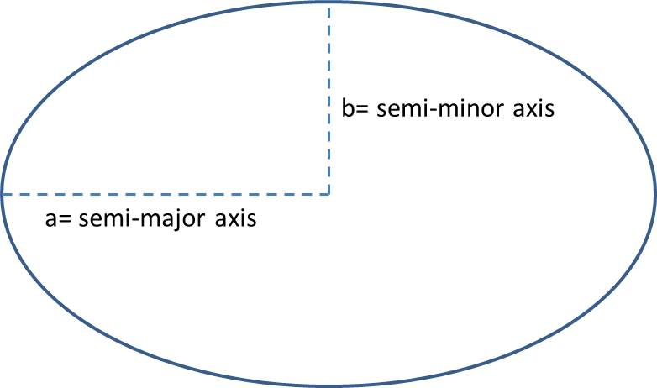
Supplementary Figure 1. Semi-major and semi-minor axes of an ellipse

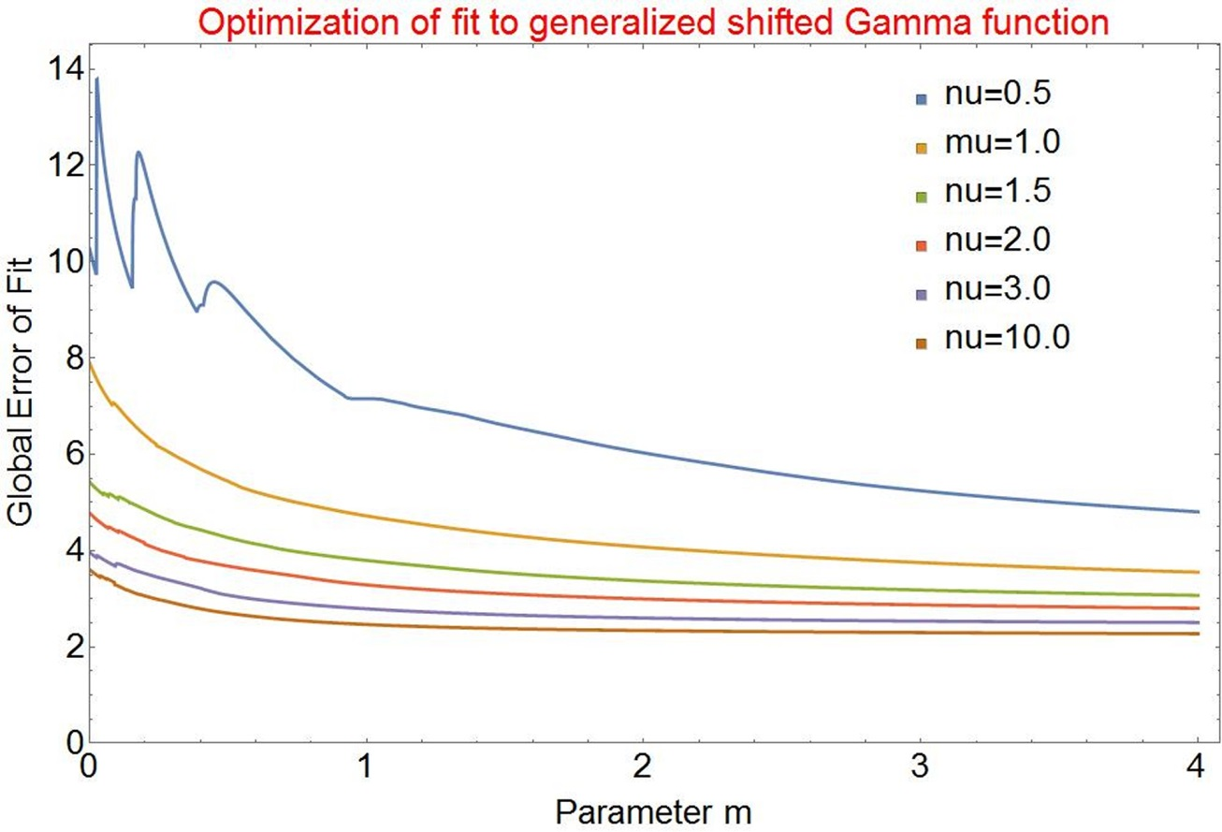
Supplementary Figure 2. Overall error for all the size distributions measured by Young et al. (2014) as a function of the size parameter $m$ for different values of $ν$ for the generalized shifted gamma distribution. The 2,2 case above is clearly in a sweet spot of maximum effectiveness for minimum complexity when one accounts for the expected variability of the sample of results from Young et al. (2014).

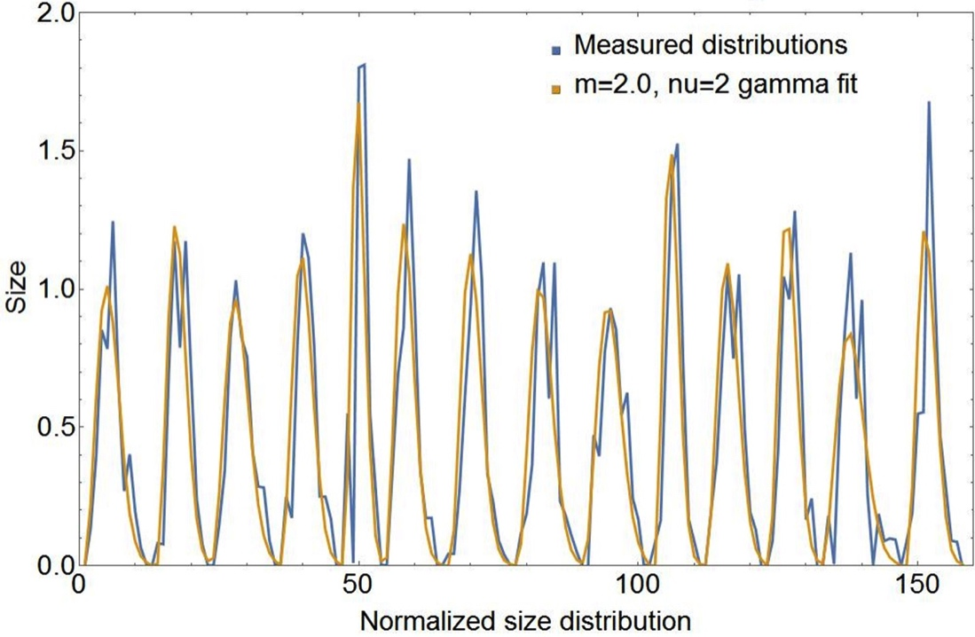

Supplementary Figure 3. Goodness of the fit to the 14 separate measured unity normalized E. huxleyi coccolith size distributions from the data of Young et al. (2014). The sampling size interval per unit is 0.2 μm.
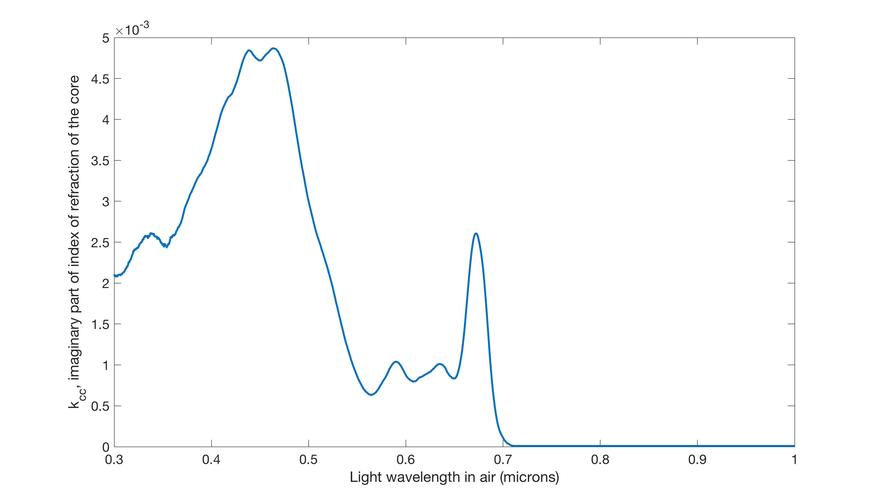
Supplementary Figure 4. Imaginary part of the index of refraction, $k\left(λ\right)$ of E. huxleyi cores determined from their absorption spectra experimentally determined by (Stramski et al., 2001) and (Neeley et al., 2015).
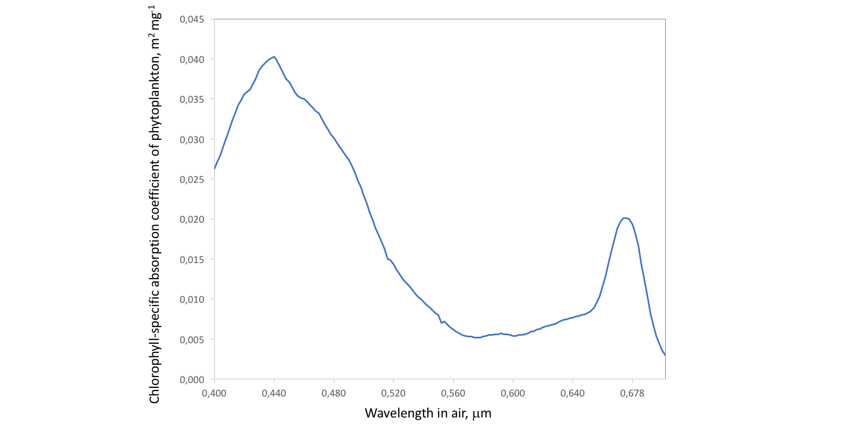
Supplementary Figure 5. Chlorophyll-a specific absorption coefficient for phytoplankton, $a_{ph}^{*}\left(λ\right)$, corresponding to Chla = 1 mg m⁻³ as determined by (Bricaud et al., 1995).

Supplementary Tables

Supplementary Table 1. Coefficients of the algebraic remote sensing reflectance of Albert and Mobley (2003).
coefficients | $R_{rs∞}$ (sr⁻¹)
$$p_{1}$$ | 0.0512 (sr⁻¹)
$$p_{2}$$ | 4.6659
$$p_{3}$$ | -7.8387
$$p_{4}$$ | 5.4571
$$p_{5}$$ | 0.1098
$$p_{6}$$ | -0.0044 (s/m)
$$p_{7}$$ | 0.4021

Supplementary references
Albert, A. and Mobley, C.D. (2003). An analytical model for subsurface irradiance and remote sensing reflectance in deep and shallow case-2 waters, Opt. Express, 11, 2873-2890
Abramowitz, M., and Stegun, I.A. (1964) Handbook of mathematical Functions (National Bureau of Standards), pp. 590-591.
Babin, M., Stramski, D., Ferrari, G. M., Claustre, H., Bricaud, A., Obolensky, G., et al. (2003). Variations in the light absorption coefficients of phytoplankton, nonalgal particles, and dissolved organic matter in coastal waters around Europe. J. Geophys. Res. 108, 3211. doi:10.1029/2001JC000882.
Bricaud, A., Babin, M., Morel, A., and Claustre, H. (1995). Variability in the chlorophyll-specific absorption coefficients of natural phytoplankton: Analysis and parameterization. J. Geophys. Res. 100, 13321. doi:10.1029/95JC00463.
Cauchy, A.-L. (1850). Mémoire sur la rectification des courbes et la quadrature des surfaces courbes. Mémoires l’académie des Sci. tome XXII, 167–177. Available at: http://gallica.bnf.fr/ark:/12148/bpt6k901828/f173 [Accessed March 26, 2018].
Gordon, H. R., O. B. Brown, R. H. Evans, J. W. Brown, R. C. Smith, K. S. Baker, and D. K. Clark. (1988). A semianalytical radiance model of ocean color. J. Geophys. Res. 93:10909–10924. doi:10.1029/JD093iD09p10909.
Fournier, G., and Neukermans, G. (2017). An analytical model for light backscattering by coccoliths and coccospheres of Emiliania huxleyi. Opt. Express 25, 14996. doi:10.1364/OE.25.014996.
Kou, L., Labrie, D., and Chylek, P. (1993). Refractive indices of water and ice in the 0.65- to 2.5-µm spectral range. Appl. Opt. 32, 3531–40.
Lee, Z., Carder, K. L., Mobley, C. D., Steward, R. G., and Patch, J. S. (1998). Hyperspectral remote sensing for shallow waters I A semianalytical model. Appl. Opt. 37, 6329. doi:10.1364/AO.37.006329.
Morel, A. 1974. Optical properties of pure water and pure sea water, p. 1–24. In N. G. Jerlov and E. Steeman Nielsen [eds.], Optical aspects of oceanography. Academic.
Neeley, A. R., Freeman, S. A., and Harris, L. A. (2015). Multi-method approach to quantify uncertainties in the measurements of light absorption by particles. Opt. Express 23, 31043. doi:10.1364/OE.23.031043.
Pope, R. M., and Fry, E. S. (1997). Absorption spectrum (380–700 nm) of pure water II Integrating cavity measurements. Appl. Opt. 36, 8710. doi:10.1364/AO.36.008710.
Ramanujan, S. (1914). Modular Equations and Approximations to π,” Quart. J. Pure App. Math. 45, 350-372.
Stramski, D., Bricaud, A., and Morel, A. (2001). Modeling the inherent optical properties of the ocean based on the detailed composition of the planktonic community. Appl. Opt. 40, 2929. doi:10.1364/AO.40.002929
Young, J. R., Poulton, A. J., and Tyrrell, T. (2014). Morphology of Emiliania huxleyi coccoliths on the northwestern European shelf – is there an influence of carbonate chemistry? Biogeosciences 11, 4771–4782. doi:10.5194/bg-11-4771-2014.
Zhai, P.-W., Hu, Y., Trepte, C. R., Winker, D. M., Josset, D. B., Lucker, P. L., et al. (2013). Inherent optical properties of the coccolithophore: Emiliania huxleyi. Opt. Express 21, 17625. doi:10.1364/OE.21.017625.
Zhang, X., Hu, L., Twardowski, M. S., and Sullivan, J. M. (2009). Scattering by solutions of major sea salts. Opt. Express 17, 19580. doi:10.1364/OE.17.019580.

